PATIENT NAME:
INSURANCE ID#: DOB:
ADDRESS:
PHONE #:

MEDICARE DESCRIPRION AND POCEDURE CODES:
- STANDARD POWER OPERATED VECHILE GROUP1:K0800#1
- BATTERY E2365 #2
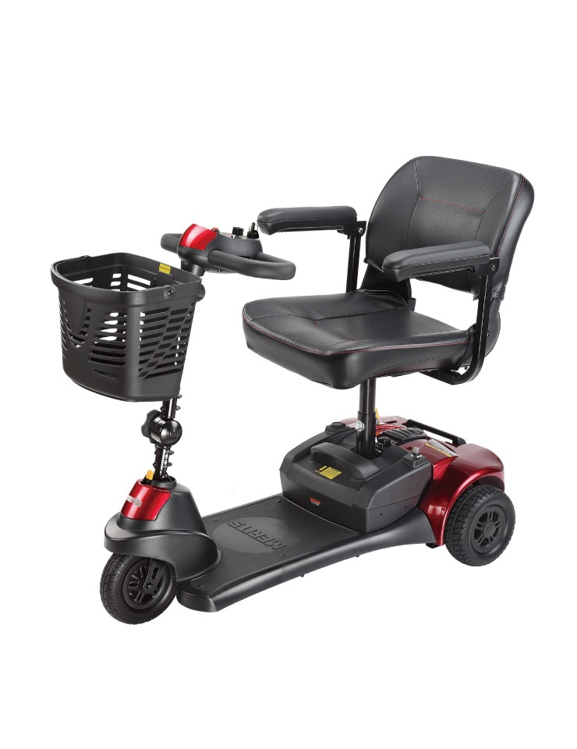
ROADSTER 3
S731A
- Tiller angle adjustable for ergonomic driving position and easy on and off.
- Loop tiller with throttle lever to maneuver by palm
or finger.
- Transport and store easily with auto latching
- lockup design.
- Detachable battery pack with built in charging port.
- Large plastic basket.
- Easily disassembles into 5 pieces.
- Extra charging port under dashboard for easy plug in.
- Non-slip foot mat.
- Simple dashboard easy to read.
- No tools needed for set-up.
- High ground clearance 5cm.

Key Details:
Driving Range | 9.5 km / 6 mi.
Max Speed | 6.5 km/h , 4 mph
Battery Type | 12V / 12AH x 2pcs
Motor | DC 24V, 110W (Rating) / 420W (Max)
Max Climbing Angle | 6°
Weight Capacity | 136 kg / 300 lb
Total Weight | 42.5 kg / 94 lb
Turning Radius | 91 cm / 36"
Ground Clearance | 5 cm / 2"
Controller | PG S-Drive 45A
Charger | 1.5A off-board
Front wheel | 8" x 2" Solid tire
Rear wheel | 8" x 70 mm Solid tire
Base | 24 kg / 53 lb
Battery | 5 kg / 11 lb
Seat | 9 kg / 20 lb
Brake | Intelligent, regenerative, electromagnetic brakes
Color | ---

As the ordering physician I approve the above described item as appropriate for the patient’s needs.

DOCTOR’S INFORMATION.

Doctor’sSignature:____________________________________________________Date:_____________
Print Name: _____________________________________ NPI#:_______________________________
Facility Name: _________________________________________________________________________
Address:______________________________________________________________________________
Phone: _______________________________________
Fax: _________________________________________

